1. 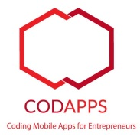**You have received an email inviting you to join an Apple Developer program :**

Level of difficulty:   
Estimated time: 20 mn

[**www.codapps.io**](http://www.codapps.io)by Clement Levallois **@codapps_io** [**www.coursera.org/learn/codapps**](http://www.coursera.org/learn/codapps)



**Module 4: Testing your app on a phone and distributing it**

*How to test your app on an iPhone - OPTION B*

*If you don’t find this email, check your spam folder !*



1. Open this email, click on the link :

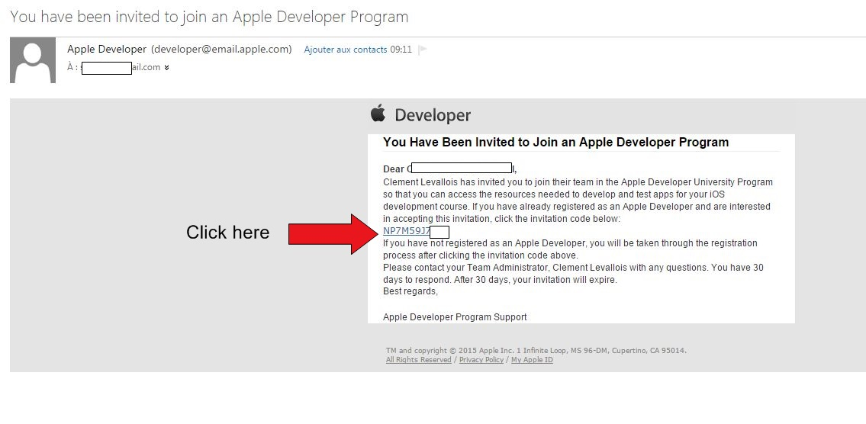

1. On the page that opens, choose « I need to register as an Apple Developer »

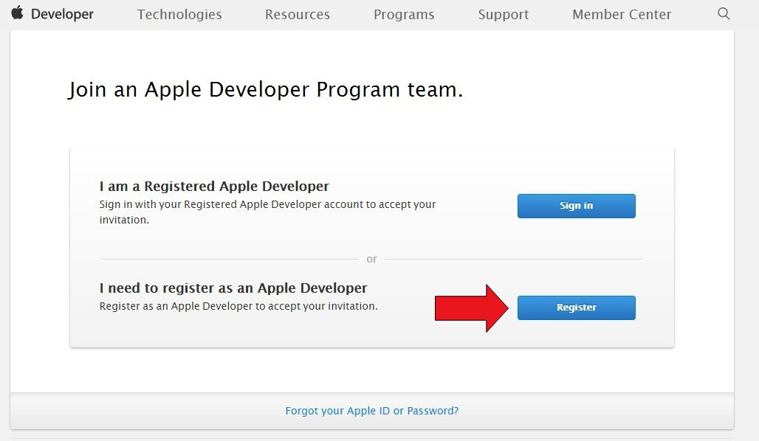

1. Then you arrive on a screen that asks you to use your Apple id.

Level of difficulty:   
Estimated time: 20 mn

[**www.codapps.io**](http://www.codapps.io)by Clement Levallois **@codapps_io** [**www.coursera.org/learn/codapps**](http://www.coursera.org/learn/codapps)



**Module 4: Testing your app on a phone and distributing it**

*How to test your app on an iPhone - OPTION B*

* 1. If you have an Apple Id (because you own a Mac, or an iPhone, or because you use iTunes…), choose « sign in »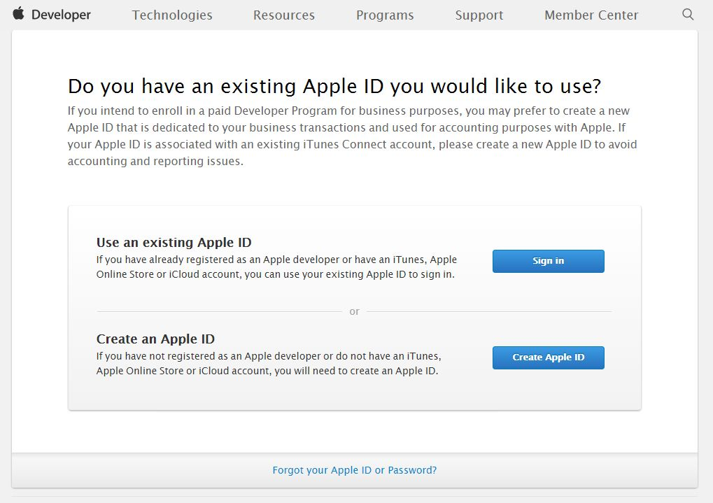
  2. If you don’t have an Apple id, choose « Create an Apple Id »

1. Then you need to agree on the license :

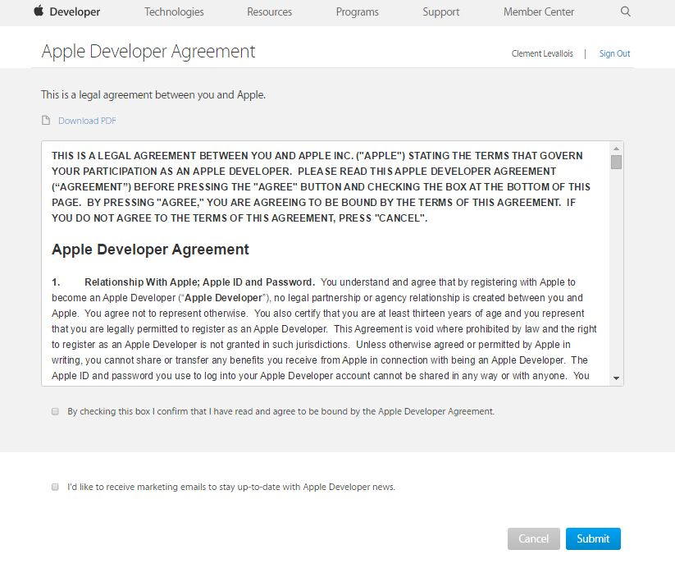

1. You should be redirected to this page, which is the place where you manage the certificates of your apps for iPhones :

Level of difficulty:   
Estimated time: 20 mn

[**www.codapps.io**](http://www.codapps.io)by Clement Levallois **@codapps_io** [**www.coursera.org/learn/codapps**](http://www.coursera.org/learn/codapps)



**Module 4: Testing your app on a phone and distributing it**

*How to test your app on an iPhone - OPTION B*

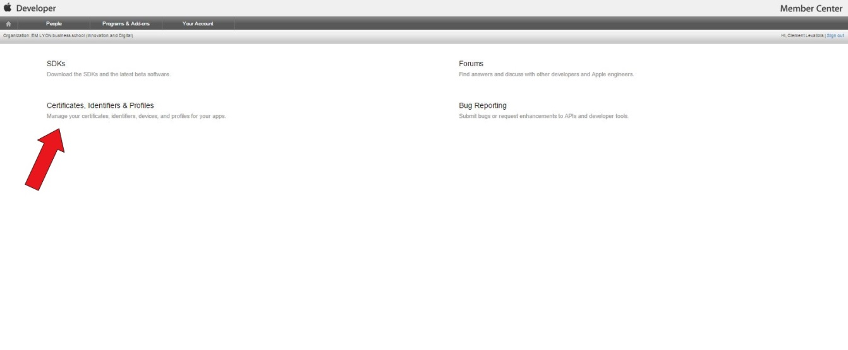

Congratulations you have a free Apple Developer account, which allows you to create certificates for your apps. These certificates will only allow you to test your apps on phones (iPhones), it is a pity they don’t authorize you to put your apps on the iTunes App Store…

Anyway, **check the next page** for the steps to create certificates to put your apps on iPhones !

**Note : you need a Mac computer, this will not work on PCs.**

1. Click on « Certificates -> All » then click on the **+** sign, to add a new certificate for your app :

Level of difficulty:   
Estimated time: 20 mn

[**www.codapps.io**](http://www.codapps.io)by Clement Levallois **@codapps_io** [**www.coursera.org/learn/codapps**](http://www.coursera.org/learn/codapps)



**Module 4: Testing your app on a phone and distributing it**

*How to test your app on an iPhone - OPTION B*

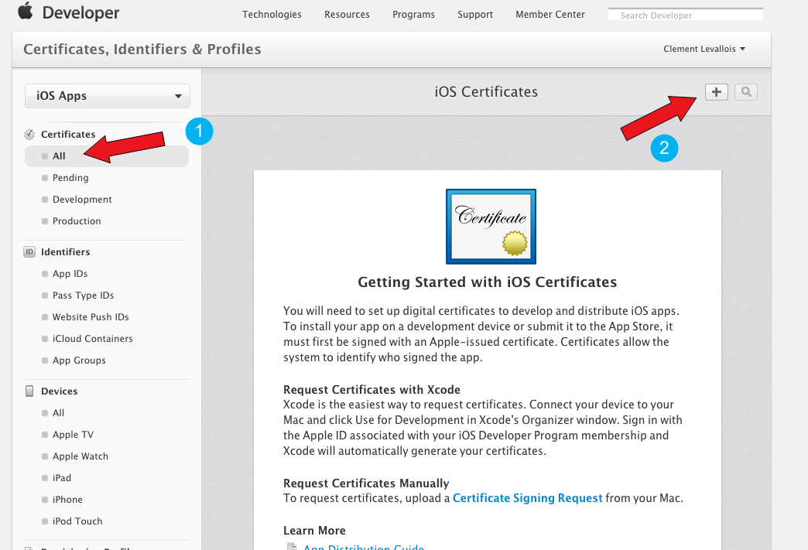

2. Choose « iOS App Development », click on « Worldwide Developer Relations Certificate Authority » (it will download a file in your « Download » folder). Then click on « Continue »

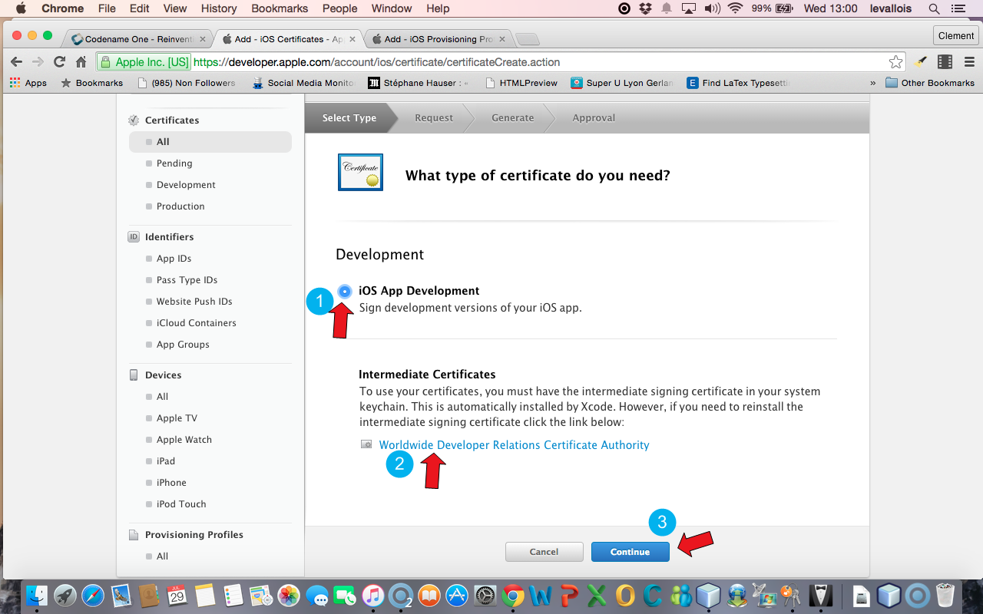

1. You should arrive on this screen, **stay on it** :

Level of difficulty:   
Estimated time: 20 mn

[**www.codapps.io**](http://www.codapps.io)by Clement Levallois **@codapps_io** [**www.coursera.org/learn/codapps**](http://www.coursera.org/learn/codapps)



**Module 4: Testing your app on a phone and distributing it**

*How to test your app on an iPhone - OPTION B*



1. 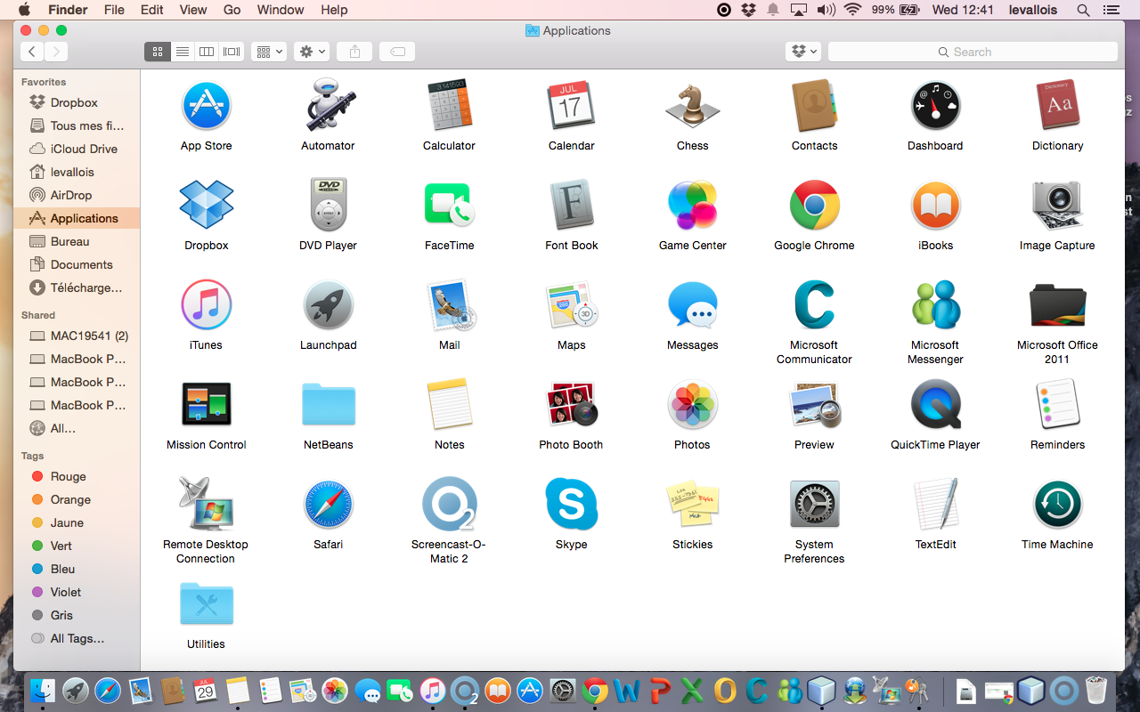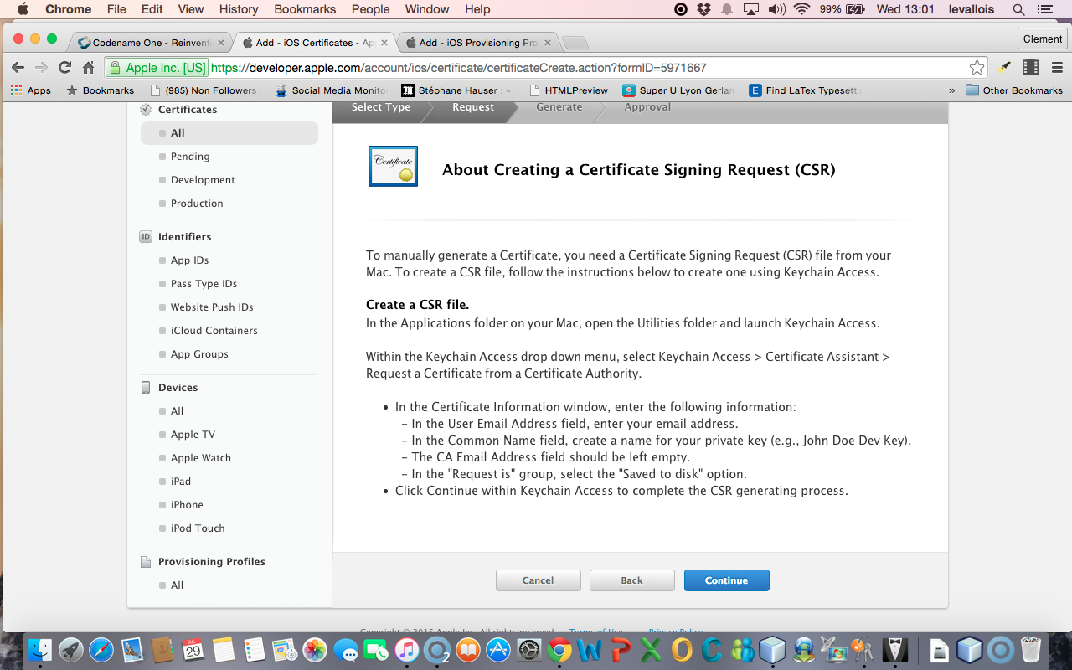In the Finder on your Mac, open the **Applications** folder ( ), and inside it, open the « **Utilities** » folder :
2. 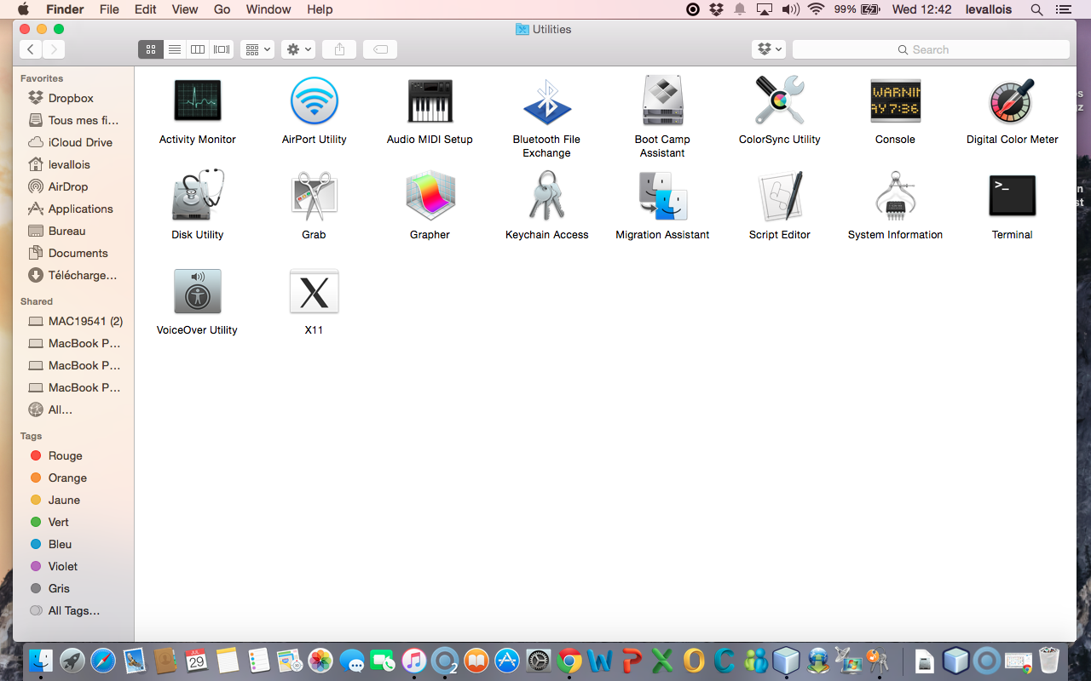In the « Utilities » folder, open the Keychain access :

Level of difficulty:   
Estimated time: 20 mn

[**www.codapps.io**](http://www.codapps.io)by Clement Levallois **@codapps_io** [**www.coursera.org/learn/codapps**](http://www.coursera.org/learn/codapps)



**Module 4: Testing your app on a phone and distributing it**

*How to test your app on an iPhone - OPTION B*

1. 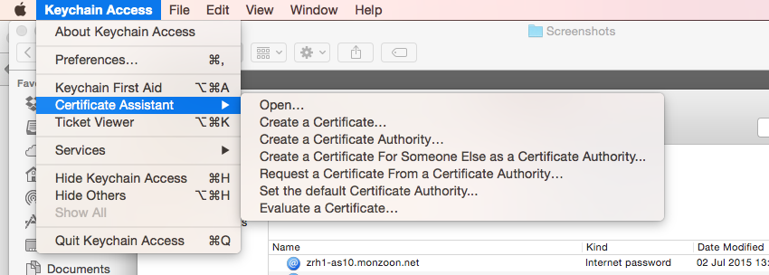In the window that opens, select in the menu « Keychain access -> Certificate Assistant -> **Request a Certificate from a Certificate Authority** »
2. In the small window that opens, please :

Level of difficulty:   
Estimated time: 20 mn

[**www.codapps.io**](http://www.codapps.io)by Clement Levallois **@codapps_io** [**www.coursera.org/learn/codapps**](http://www.coursera.org/learn/codapps)



**Module 4: Testing your app on a phone and distributing it**

*How to test your app on an iPhone - OPTION B*

* In te field « User email address », put the email address of your Apple ID
* In the field « Common Name », put your emlyon email address
* Then choose « save to disk » and click on « continue ». **I suggest you create a folder somewhere on your computer called « Apple certificates », where you will save the file**.

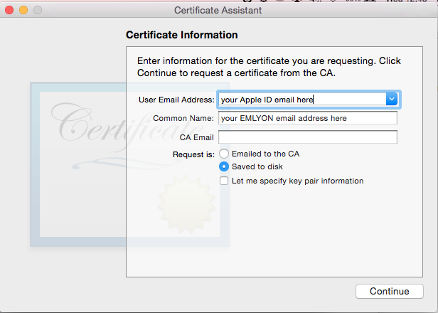

1. Now, let’s go back to the website of the Apple Dev Center, where we can continue where we left !

* If there is an error on the page, it just means that the page expired. Just reload it, and go back to the screen where we were at the step 8 of this document.

1. Upload the file « CertificateSigningRequest.certSigningRequest » that you just saved.on your disk :

Level of difficulty:   
Estimated time: 20 mn

[**www.codapps.io**](http://www.codapps.io)by Clement Levallois **@codapps_io** [**www.coursera.org/learn/codapps**](http://www.coursera.org/learn/codapps)



**Module 4: Testing your app on a phone and distributing it**

*How to test your app on an iPhone - OPTION B*

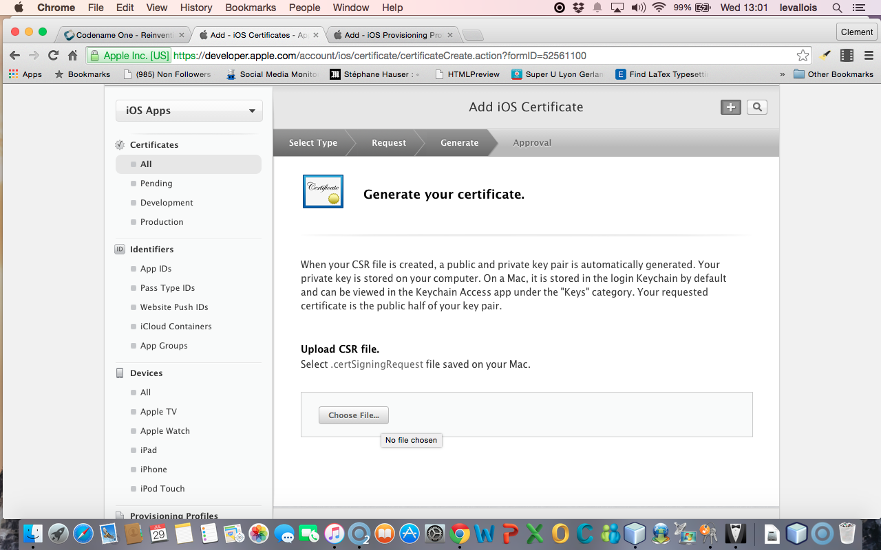

1. 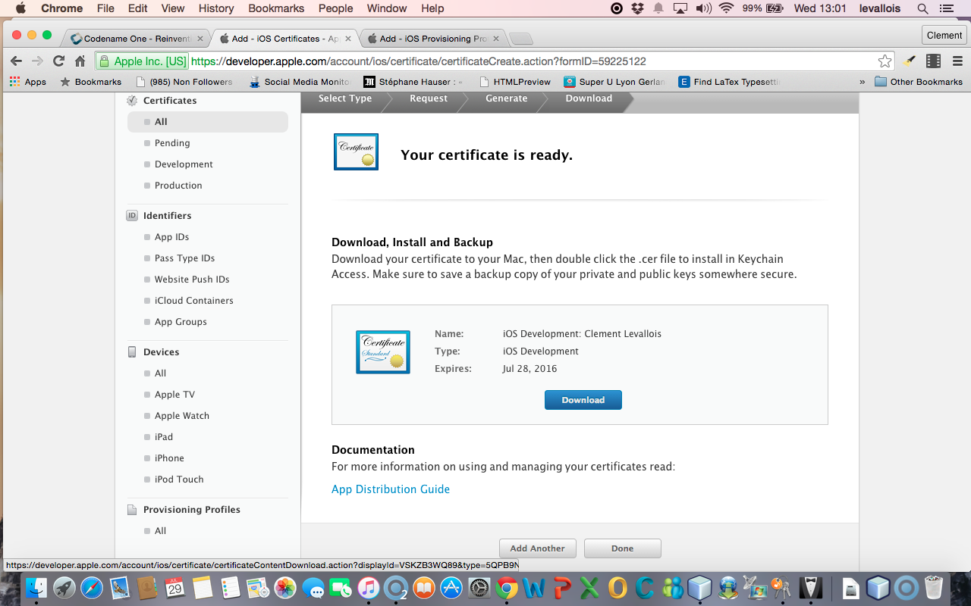This creates your certificate.Now download it to your disk, in the same folder. It should be called « ios_development.cer » :
2. Find your file « ios_development.cer » where you saved it. Double click on it. This will open the Keychain access.

Level of difficulty:   
Estimated time: 20 mn

[**www.codapps.io**](http://www.codapps.io)by Clement Levallois **@codapps_io** [**www.coursera.org/learn/codapps**](http://www.coursera.org/learn/codapps)



**Module 4: Testing your app on a phone and distributing it**

*How to test your app on an iPhone - OPTION B*

* click on « Certificates » in the left menu
* Right click on the name of your certificate and choose « Export… »

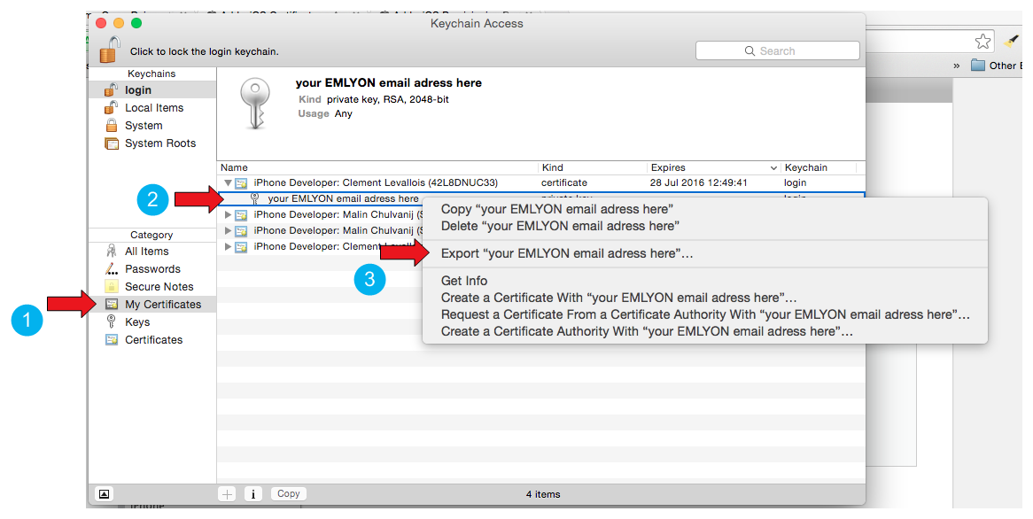

1. This opens a window asking for a password. Put “**emlyon1000**”

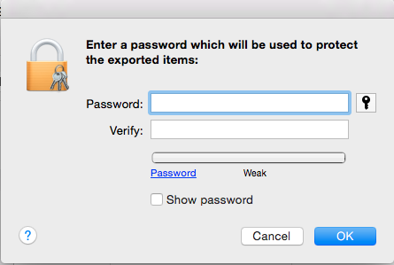

1. Then on the next screen you are asked again for a password. You should use the password of your Mac computer (the one you use to login when the computer starts) :

Level of difficulty:   
Estimated time: 20 mn

[**www.codapps.io**](http://www.codapps.io)by Clement Levallois **@codapps_io** [**www.coursera.org/learn/codapps**](http://www.coursera.org/learn/codapps)



**Module 4: Testing your app on a phone and distributing it**

*How to test your app on an iPhone - OPTION B*

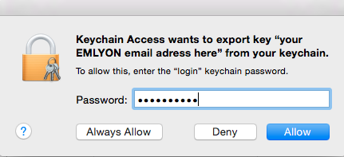

1. Finally, you are invited to save a file on your disk. This is a file with « p12 », save it in the same folder where you saved your other files for this certificate.
2. We need the UDID of your phone (anyone still reading this ? if so, you win the code #Isurvived for [www.leaderboard.codapps.io](http://www.leaderboard.codapps.io))

The UDID is the unique identifier of your iPhone. You can find it by plugging your phone to iTunes. A very simple tutorial explains it here : <http://whatsmyudid.com/>

1. Once you have your UDID, send it to me here: <http://goo.gl/forms/mmotEWvRYs>

And **now wait just a couple of days**… I need to collect all UDID from students before I create “Provisioning Profiles” (yes, this process is long and horrible, but we are NEARLY there!).

I’ll send you an email when you can resume this pdf, at step 22 (**see next page**):

1. Go to “Provisioning Profiles” and download the **most recent one**:

Level of difficulty:   
Estimated time: 20 mn

[**www.codapps.io**](http://www.codapps.io)by Clement Levallois **@codapps_io** [**www.coursera.org/learn/codapps**](http://www.coursera.org/learn/codapps)



**Module 4: Testing your app on a phone and distributing it**

*How to test your app on an iPhone - OPTION B*

*I advise you to download it to the same folder where you saved the previous files created in this tutorial, related to certificates*

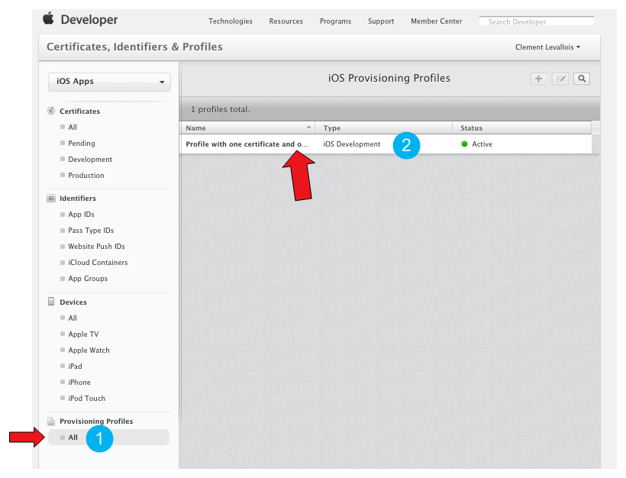

1. Now, open NetBeans, right click on the name of your project, and select “Properties” (last item at the bottom).

**(continued next page)**

1. Please check the screenshot below and the numbered steps, and read the indications for each of them:

Level of difficulty:   
Estimated time: 20 mn

[**www.codapps.io**](http://www.codapps.io)by Clement Levallois **@codapps_io** [**www.coursera.org/learn/codapps**](http://www.coursera.org/learn/codapps)



**Module 4: Testing your app on a phone and distributing it**

*How to test your app on an iPhone - OPTION B*

1. Select “iOS” on the menu on the left
2. For Certificate, choose the file with the name ending in “p12” that you saved on your computer at the **step 19** of this tutorial
3. For Certificate password, write “emlyon1000”
4. For provisioning profile, choose the one we just downloaded in **step 22**
5. In app ID, you must add “**4RVRDEN5JP.**” Just before io.codapps
6. Validate

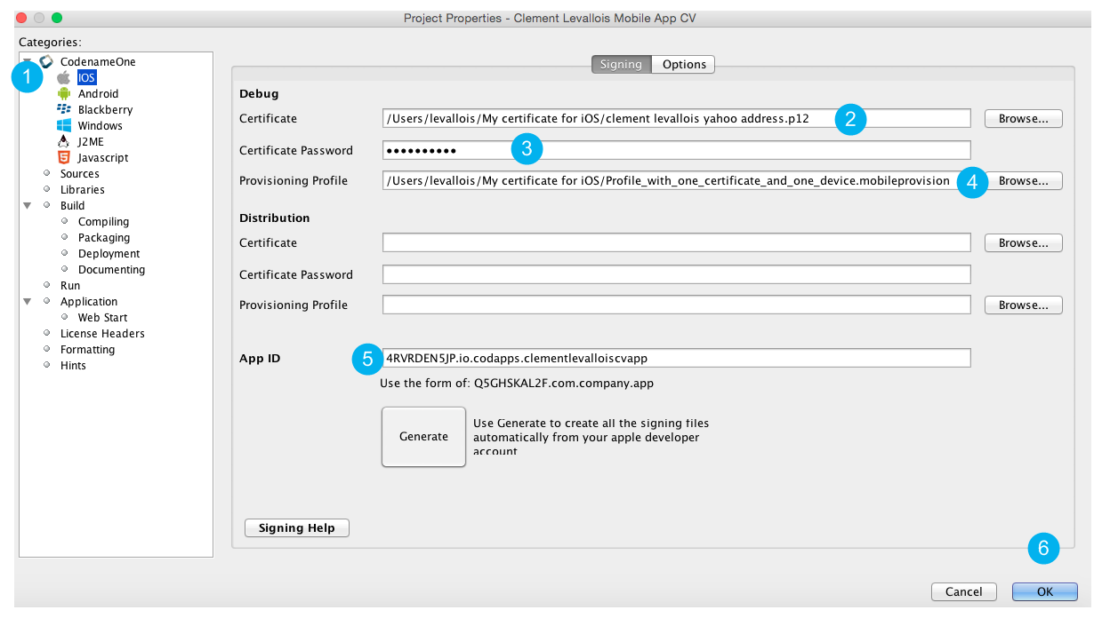

1. See next page
2. You need first to create a free account with Codename One (the tool we use to create apps).

To do so, visit their website at www.codenameone.com and select “Sign up”.

Choose the free version. You are not obliged to choose to receive the newsletter.

**Please open the confirmation email you will receive and click on the link** in it to confirm the creation of your account.

1. In NetBeans, right click on the title of your project and select “Send iOS Debug Build”

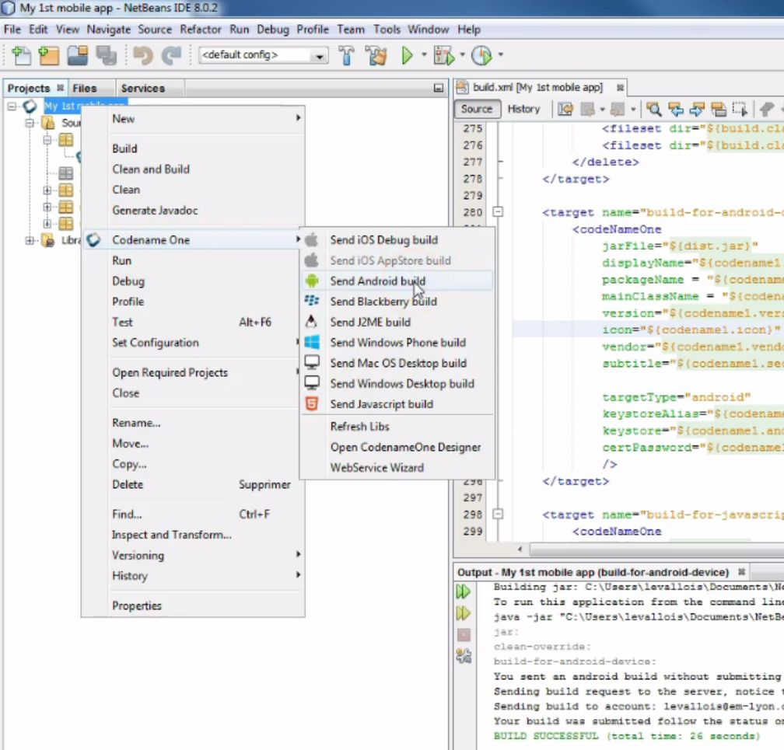

Level of difficulty:   
Estimated time: 20 mn

[**www.codapps.io**](http://www.codapps.io)by Clement Levallois **@codapps_io** [**www.coursera.org/learn/codapps**](http://www.coursera.org/learn/codapps)



**Module 4: Testing your app on a phone and distributing it**

*How to test your app on an iPhone - OPTION B*

This starts the creation of package ready to be sent to Codename One. An alert windows will ask you for the login and password of your Codename One account, please enter them.

Level of difficulty:   
Estimated time: 20 mn

1. You know the process finished successfully when you see this in the bottom panel of NetBeans:

**Note**: you don’t see this output window at the bottom of NetBeans? In this case, in the menu of NetBeans, select “Windows” then “Output”, it should make it appear:

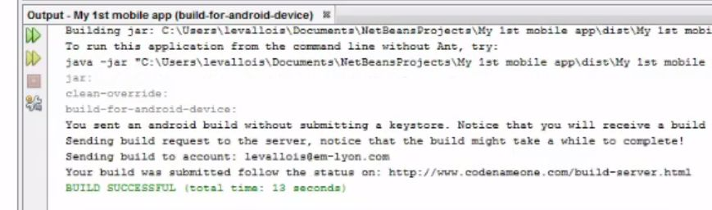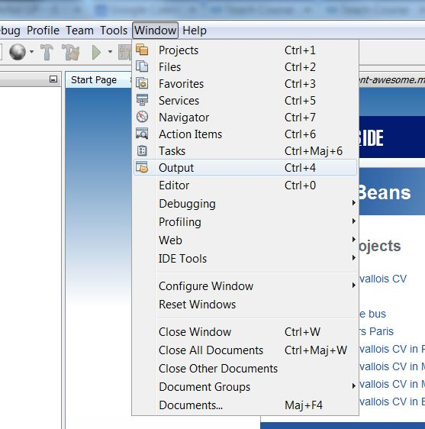

**Module 4: Testing your app on a phone and distributing it**

*How to test your app on an iOS phone - OPTION B*



[**www.codapps.io**](http://www.codapps.io)by Clement Levallois **@codapps_io** [**www.coursera.org/learn/codapps**](http://www.coursera.org/learn/codapps)



1. You can now go back to the website of Codename One, where your app has been sent to create the iOS version of it. Login, then go the the Dashboard (in the menu on top of the page).

Level of difficulty:   
Estimated time: 45 mn

1. You will see the status of your app:

* blue -> in progress
* green -> finished, ready to be used
* red: something went wrong, your iOS app could not be created.

1. When the status turns green, click on it. A series of option appears to install your app on your iOS phone:

* A QR code: flash the QR code from your iPhone, this will download the app on your phone and you’ll be able to install it.
* An email link: click on it, and an email will be sent to the email address of your Codename One account. Open this email **from your phone**, click the link in it and this will start the download + installation process

[**www.codapps.io**](http://www.codapps.io)by Clement Levallois **@codapps_io** [**www.coursera.org/learn/codapps**](http://www.coursera.org/learn/codapps)



**Module 4: Testing your app on a phone and distributing it**

*How to test your app on an iOS phone*